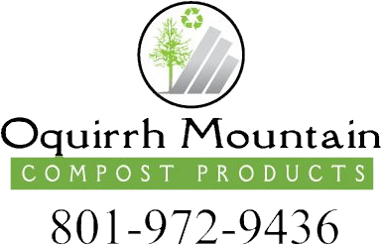
DELIVERY FEES
2021
January 1, 2021
Oquirrh mountain compost products
800 W Central Valley Rd, South Salt Lake, UT 84119

City | Delivery Fee | Miles | Cost per Mile
UTAH COUNTY
Lehi | $30 | 12 | $2.50
Alpine | $50 | 20 | $2.50
Highland | $40 | 16 | $2.50
Orem | $80 | 32 | $2.50
Provo | $100 | 40 | $2.50
Eagle Mountain | $90 | 36 | $2.50
Spanish Fork | $170 | 65 | $2.50
Payson | $180 | 70 | $2.50
Salem | $200 | 70 | $2.75
Elk Ridge | $220 | 80 | $2.75
DAVIS COUNTY
Bountiful | $40 | 16 | $2.50
West Bountiful | $40 | 16 | $2.50
North Salt Lake | $30 | 12 | $2.50
SUMMIT COUNTY
Midway | $160 | 52 | $3.00
Oakley | $160 | 52 | $3.00
Park City | $90 | 28 | $3.00
TOOELE COUNTY
Lake Point | $50 | 18 | $2.50
Stansbury Park | $60 | 22 | $2.50
Erda | $50 | 20 | $2.50
Grantsville | $90 | 35 | $2.50
Tooele | $80 | 31 | $2.50
Stockton | $120 | 45 | $2.50
WEBER COUNTY
Ogden | $200 | 70 | $2.75
SALT LAKE COUNTY
Millcreek | No Charge
Murray | No Charge
Bluffdale | No Charge
Herriman | No Charge
Cottonwood Heights | No Charge
Draper | No Charge
Holladay | No Charge
Kearns | No Charge
Magna | No Charge
Midvale | No Charge
Riverton | No Charge
Salt Lake City | No Charge
Sandy | No Charge
South Jordan | No Charge
West Jordan | No Charge
West Valley City | No Charge
Taylorsville | No Charge

